 | 7.1.32 Editors - 3D Viewport - Header - Grease Pencil - Edit mode - Stroke menu
Table of content
Edit Mode - Stroke Menu 3
Subdivide 3
Last Operator Subdivide 3
Number of Cuts 3
Smooth 3
Repeat 3
Selected Points 3
Position 3
Thickness 3
Strength 4
UV 4
Subdivide and smooth 4
Last Operator Subdivide 4
Number of Cuts 4
Selected Points 4
Iterations 4
Factor 4
Smooth Endpoints 4
Keep Shape 4
Position 4
Radius 4
Opacity 4
Simplify 5
Fixed 5
Last Operator Simplify Fixed Stroke 5
Steps 5
Adaptive 5
Last Operator Simplify Stroke 5
Factor 5
Sample 5
Last Operator Sample Stroke 5
Length 5
Merge 5
Last Operator Merge 5
Distance 5
Join submenu 5
Join and Copy 5
Join 6
Adjust last operator Join Selection 6
Type 6
Outline 6
Adjust last operator Outline 6
Projection mode 6
Radius 6
Offset Factor 6
Corner Subdivisions 6
Move to Layer 6
New Layer 6
Last Operator Move Strokes to Layer 7
Grease Pencil Layer 7
Assign Material 7
Last Operator Change Stroke Color 7
Material 7
Set as active material 7
Arrange 7
Bring Forward 8
Send Backward 8
Bring to Front 8
Send to Back 8
Last Operator Arrange Stroke 8
Direction 8
Close 8
Toggle Cyclic 8
Last Operator Set Cyclical State 8
Type 8
Close all 8
Open all 8
Toggle 8
Create geometry 8
Set Caps 9
Default 9
Both 9
Start 9
End 9
Last Operator Set Caps Mode 9
Type 9
Switch Direction 9
Set Start Point 9
Normalize Thickness 9
Normalize Opacity 10
Last operator Normalize Stroke 10
Mode 10
Value 10
Set Curve Type submenu 10
Set Curve Resolution 10
Ajust last operator Set Curve Resolution 10
Resolution 10
Outline 10
Last operator Convert Stroke to Outline 11
View 11
Material Mode 11
Thickness 11
Keep Shape 11
Subdivisions 11
Sample Length 11

Edit Mode - Stroke Menu
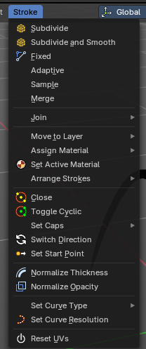
In Edit Mode you will also see a add menu for some object types. The number of objects that you can add is limited to the same object type that you are in edit mode with. You can just add mesh geometry to a mesh geometry. And just curve geometry to curve geometry.
The added objects in edit mode becomes part of the current object geometry.

Subdivide
Subdivides the selected grease pencil geometry.

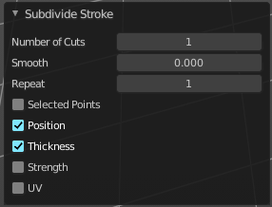
Last Operator Subdivide

Number of Cuts
Number of subdivision cuts.

Smooth
Smoothen the stroke, not just the new added vertices

Repeat
The number of times to repeat the procedure.

Selected Points
Limits the effect to only the selected points within the stroke.

Position
The operator affects the points location.

Thickness
The operator affect the points thickness.

Strength
The operator affect the points strength (alpha).

UV
The operator affect the UV rotation on the points.

Subdivide and smooth
Subdivides the selected grease pencil geometry, and smoothens it.

Last Operator Subdivide

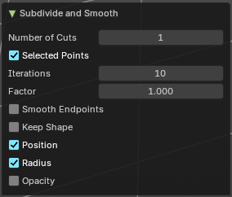
Number of Cuts
Number of subdivision cuts.

Selected Points
Limits the effect to only the selected points within the stroke.

Iterations
How often to smooth.

Factor
The smoothing factor

Smooth Endpoints
Smoothen the endpoints.

Keep Shape
Try to keep the original shape.

Position
The operator affects the points location.

Radius
The smooth radius around vertices.

Opacity
The smooth opacity.

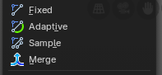
Simplify
Simplifies the stroke.

Fixed
Deletes every second point in the stroke, except the start and end points.

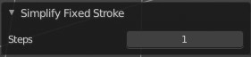
Last Operator Simplify Fixed Stroke

Steps
How much levels of simplifying.

Adaptive
This method uses an algorithm called RDP algorithm (Ramer-Douglas-Peucker algorithm) for points deletion. The algorithm tries to keep the shape with the remaining points.

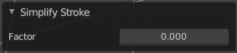
Last Operator Simplify Stroke

Factor
How strong the simplification should be performed.

Sample
Samples points along the shape of the stroke, and increases the length of the edges.

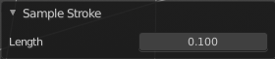
Last Operator Sample Stroke

Length
How long the edges between the points should be.

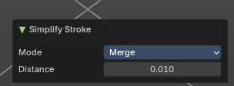
Merge
Merge and simplify selected strokes.

Last Operator Merge

Distance
How long the distance between the points should be before being simplified.

Join submenu

Join and Copy
Copy the selection in the new stroke.

Join
Move the selection to the new stroke.


Adjust last operator Join Selection

Type
Choose the join method.

Outline
Convert selected strokes to perimeter.

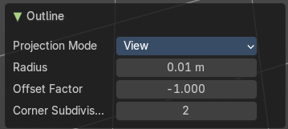
Adjust last operator Outline

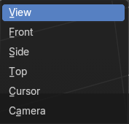
Projection mode
How to project the stroke.

Radius
How big.

Offset Factor
Offset from the stroke.

Corner Subdivisions
How much subdivisions at corners.

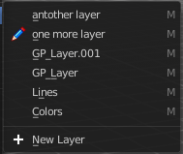
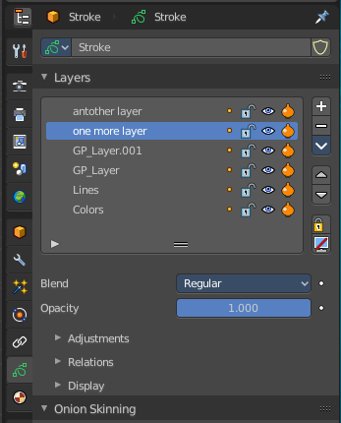
Move to Layer
Move the current selected stroke to another grease pencil layer. It lists the current layers.

New Layer
New Layer button adds a new grease pencil layer.

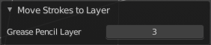
Last Operator Move Strokes to Layer

Grease Pencil Layer
Internal the layers are enumerated. So here you move by number.
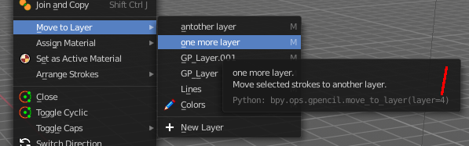
The number of a layer can be found out in the tool tip, in the Python part of it.

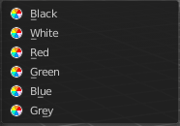
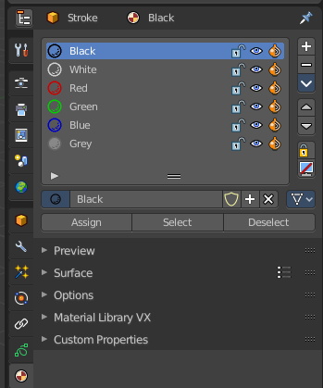
Assign Material
Assign a new material to the current selected stroke geometry.
The materials can be found and edited in the Properties editor. Here you can also create new materials.

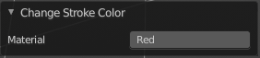
Last Operator Change Stroke Color

Material
The materials are defined by its name. So when you want to use another material, then change the name here.

Set as active material
Sets the current selected material as the active material.

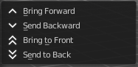
Arrange
Changes the drawing order of the strokes in the 2D layer.

Bring Forward
Moves the selected points/strokes upper the next one in the drawing order.

Send Backward
Moves the selected points/strokes below the previous one in the drawing order.

Bring to Front
Moves to the top the selected points/strokes.

Send to Back
Moves to the bottom the selected points/strokes.

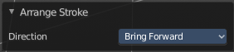
Last Operator Arrange Stroke

Direction
Choose the method again.

Close
Closes the current stroke by connecting the first vertice with the last vertice by a stroke. See also Toggle Cyclic.

Toggle Cyclic
When the curve is open, then it Closes the current stroke by connecting the first vertice with the last vertice by a stroke. When the curve is closed, then it removes the connection between first and last vertice, and makes the curve open.

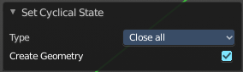
Last Operator Set Cyclical State

Type
Choose the method again.

Close all
Close all open selected strokes.

Open all
Open all closed selected strokes.

Toggle
Close or Open selected strokes as required.

Create geometry
When enabled, points are added for closing the strokes like when using the Close tool. If disabled, the stroke is closed with just one edge.

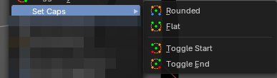
Set Caps
Toggles if the start and endpoints of the strokes are rounded or flat.
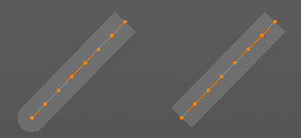

Default
Sets stroke start and end points to rounded (default).

Both
Toggle stroke start and end points caps to flat or rounded.

Start
Toggle stroke start point cap to flat or rounded.

End
Toggle stroke end point cap to flat or rounded.

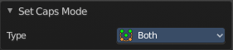
Last Operator Set Caps Mode

Type
Choose the method again.

Switch Direction
Switches the direction of the stroke geometry.

Set Start Point
Select which point is the start point of the grease pencil curve. This defines the order of point indices, useful for Geometry nodes.
Note: Not available in stroke selection mode.

Normalize Thickness
Adjust the thickness of the stroke.

Normalize Opacity
Adjust the opacity of the stroke.

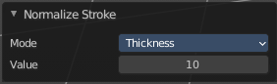
Last operator Normalize Stroke
This last operator works for both tools, Normalize Thickness and Normalize Opacity.

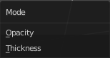
Mode
Adjust thickness or opacity.

Value
The value to adjust the opacity or thickness.

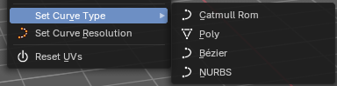
Set Curve Type submenu
Set the curve type.

Set Curve Resolution
Set the resolution of the curve.

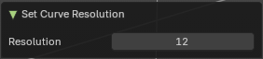
Ajust last operator Set Curve Resolution

Resolution
The resolution that you want to choose.

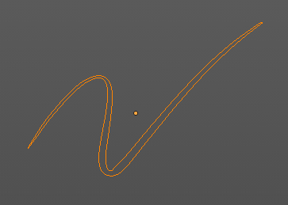
Outline
Converts the outline of the stroke to a new stroke and removes the original stroke.

This tool requires to have a ACTIVE camera in the scene, since the outline is created from this active camera. And the outline is created from exact this view of the camera. So better switch to camera view to check if the view fits.

The active camera has the active orange triangle above the widget. You can also see the active camera in the Scene properties.
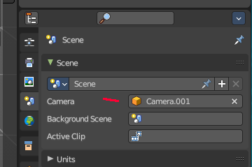
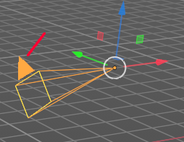

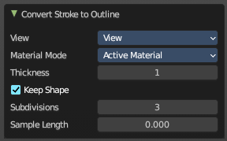
Last operator Convert Stroke to Outline

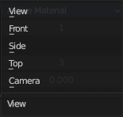
View
From which view to calculate the outline.

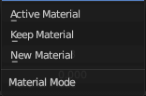
Material Mode
What material to assign to the new stroke.

Thickness
The thickness of the new stroke

Keep Shape
Try to keep global shape when the stroke thickness changes.

Subdivisions
How many subdivisions the new stroke has

Sample Length
Sample length of the stroke.

